Computer Networks Lab

Name:
Dawood Sarfraz
Roll no:
20P-0153
Section:
BSCS-5B

FAST NUCES Pwr Campus

Computer Networking Lab:
09

TASK # 01:
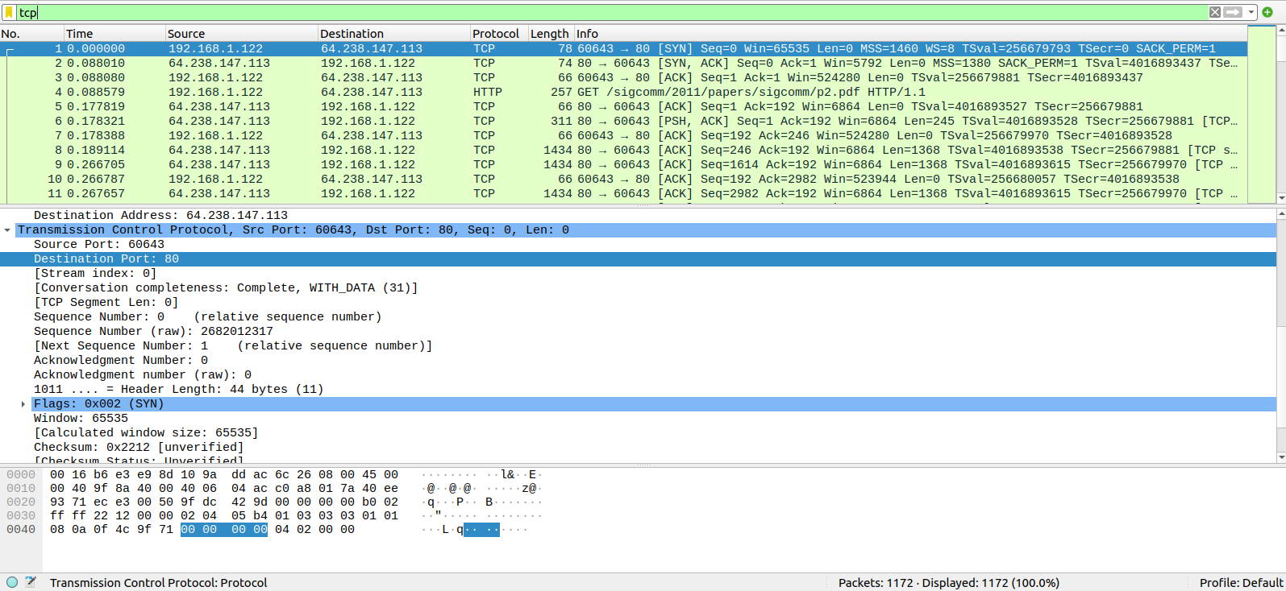
Source : 60643
Destination: 80

TASK # 02:
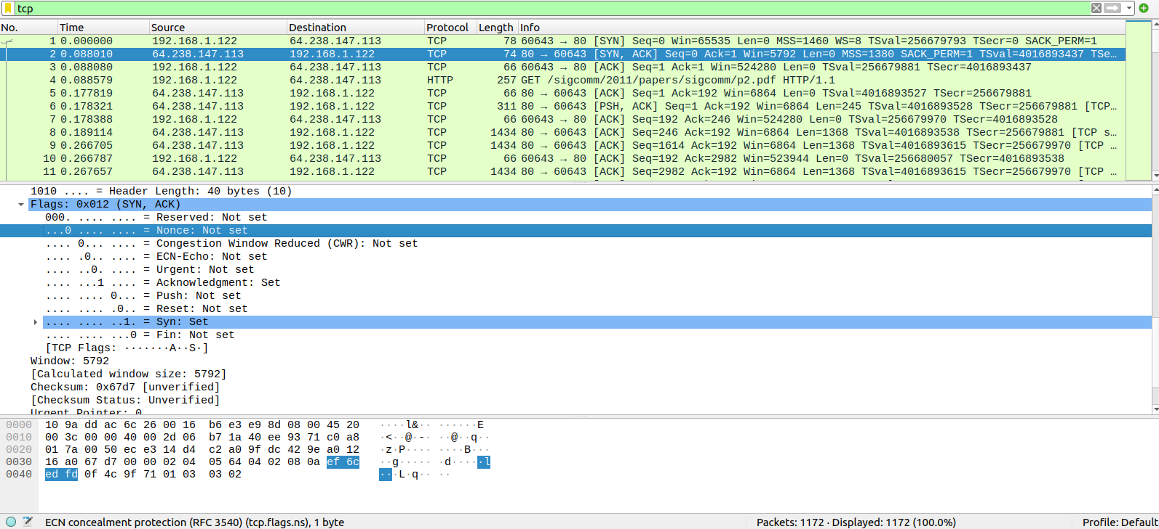
The sequence number of the TCP SYN segment is 0 since it is used to imitate the TCP connection between the client computer. In the Flags section, the Syn flag is set to 1 which indicates that this segment is a SYN segment.

TASK # 03:
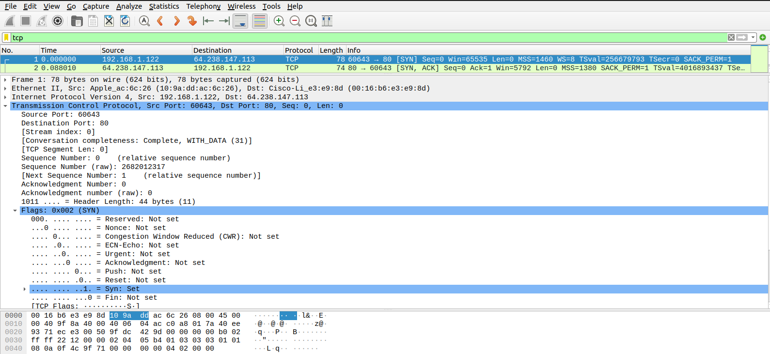
The sequence number of the SYNACK segment sent to the client computer in reply to the SYN is 0. The value of the acknowledgement field in the SYNACK segment is 1. The value of the acknowledgement field in the SYNACK segment is determined by the server . The server adds 1 to the initial sequence number of SYN segment form the client computer. For this case, the initial sequence number of SYN segment from the client computer is 0, thus the value of the acknowledgement field in the SYNACK segment is 1. A segment will be identified as a SYNACK segment if both SYN flag and Acknowledgement in the segment are set to 1.

TASK # 04:
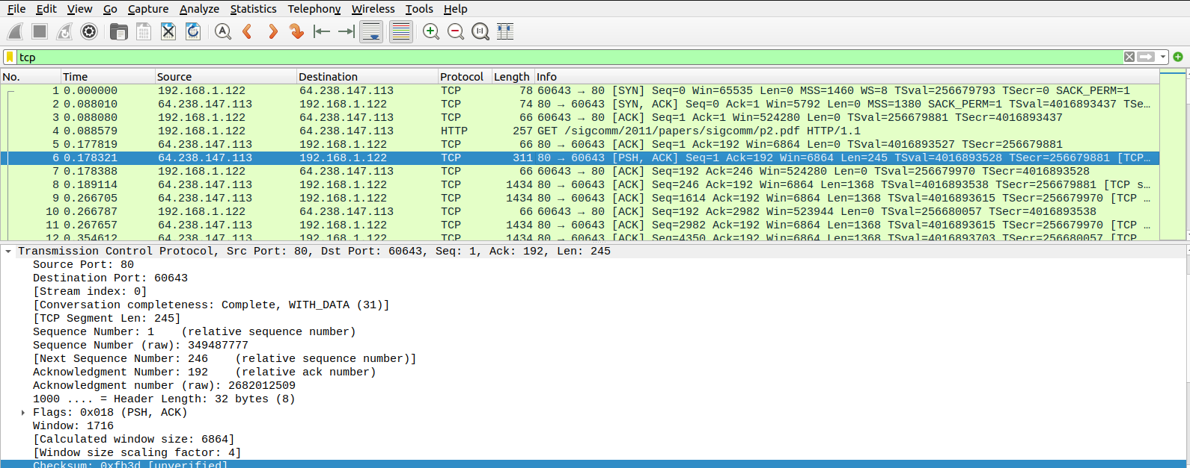

Length : 1→0
2→0
3→0
5→0
6→245

TASK # 05:

There is no retransmitted segments in the trace file since in the time sequence graph by applying Graph Filter, all sequence numbers are monotonically increasing.

